

4339 IndiviDUal Project

User Technical Guide



December 2, 2020

CIS 4339

Afzal Khazi

Welcome to the Rent a Kitten Application!

In this User Guide, I will walk you through running the application perfectly on your machine, so you too can choose among the kittens and rent one.

*Preparing the environment for setup*

For the code to run, be opened, and examined, the proper software must be installed on your machine.

*Step 1. Install VSCode:*

Navigate on your browser to the link: https://code.visualstudio.com/download and choose the appropriate version for your operating system. Run through the setup and choose all defaults.

Once VSCode has been successfully installed you should see this screen when you open it up

*Step 2. Install Robo 3T*

Your next step is to install Robo 3T. This will allow you to import all the kittens and view them stored in the database.

Navigate to the link <https://robomongo.org/download> and download Robo 3T

When you are finished you should see this screen after running through the installation

Once you have completed this step, you may move on to Step 3.

*Step 3: Install Node.js*

Step 3 involves installing Node.js. Navigate to the link <https://nodejs.org/en/download/> and you should see this window

This process will take a while. Simply wait and let your computer do the installing. Node.js and yarn are needed to run this project.

*Step 4: Installing yarn (optional)*

This step isn’t necessary, but you can choose to complete it. Follow the link to <https://classic.yarnpkg.com/en/docs/install/#windows-stable> and download yarn.

The screen should look like

*Step 5: Open folder into VSCode*

The project is currently in a zipped folder. Extract the files into a folder and navigate to



Open file directory and click on project folder. It should automatically open up.

Right now, you won’t be able to see anything. Next, navigate to a terminal.



In the upper bar where the navigation bar is, there is a button on the far right that is labelled “Terminal”. Click on it and click on “New Terminal” from the dropdown list. A new terminal should open.

*Step 6. Create Database and Collection*

The next step is to create a database and collection with the exact same names as I did. Make sure your database name is “myCats” and your collection name is “kittens”. Add some sample data if you would like it to display in the “View All Kittens” page – however, this is not absolutely necessary.

*Step 7. Run Application*

Open a split terminal. In one terminal, type “node server.js” to start the server on port 4000. In the other terminal, type “yarn add nodemon” to show changes without reloading the page and “then yarn serve”. Congratulations! The application should now be running. It should be successfully connected to MongoDB and be able to perform all CRUD operations and reflect them in the database you created if everything has been set up correctly.

Application Performance:

These are the screens you should be seeing:

Home -

Create

View All – with my sample data

View One

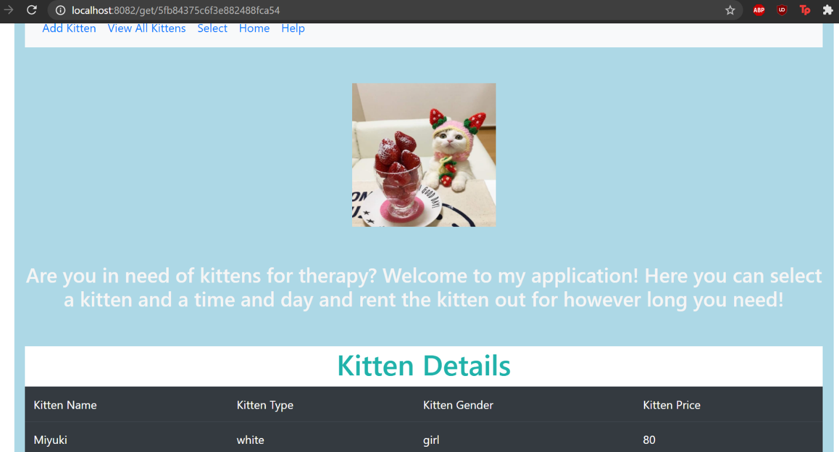

Select

FAQs and Help section

Search Results and Demand Justification

My application idea is completely unique as seen by the above screenshot. There would be a high demand for my application as cats are extremely good for promoting good mental health and aiding in emotional stability. During this time, since we are all in quarantine and struggling with human contact as well as lack of social situations to boost our energy and mood, renting a cat for happiness would be a wonderful idea. Anyone would simply choose a cat from my list, pay the price per day to keep the cat, and enjoy the cat’s company. All our cats would be well house and human trained. If someone had a cat they couldn’t take care of anymore, instead of giving the cat away to the animal shelter where it would be lonely, they could simply give the cat to us and we would rent the cat to other loving humans. I sourced most of my justification from articles such as https://www.akcreunite.org/catsimprovementalhealth/.

My Components:

I have multiple components. Each of my components leads to a page in my application and performs some sort of function.

The list and explanation of my components are as follows:

1. Create – Adds new kittens to database using a form
2. Edit – Edits information of kittens already available
3. Index – Displays all of the kittens in a table with options to edit, delete, or view
4. Help – Shows FAQs
5. Select – Allows you to select one kitten from the database. Multiple selection options are not available at this time.
6. View - Allows you to view individual kittens in greater detail.

References:

1. <https://investmentnovel.com/vue-js-crud-example-tutorial-from-scratch/#14_Perform_Edit_and_Update_operations>
2. <https://medium.com/@ctnicholas/create-a-searchable-dropdown-list-in-vue-js-139dd064e845>
3. <https://www.akcreunite.org/catsimprovementalhealth/>